Caller/User: <http://localhost:5000/caller.html?target=911>

Receiver/PSAP: <http://localhost:5000/psap.html?login=911&auto=true>

1. Why do we need “Busy” and “Decline” options at Receiver end (PSAP) when we are developing an app to handle an emergency?

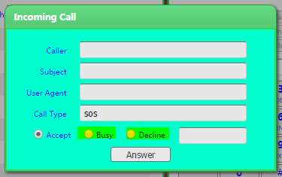

1. How to end the call after answering the user call? I don’t see any option to disconnect the call. I must refresh the page every time to disconnect the call else, I won’t receive any new calls.
2. After initiating the call, if I click on End button, video frame which displays PSAP user or receiver will be disconnected. This is incorrect behaviour, call should be disconnected from caller end.
3. I cannot make a new call after performing above sequence, because the End button is not functioning as expected.

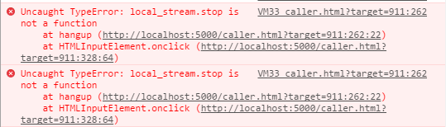

After clicking “End” button app should call local_stream.stop() method inside hangup() method. Which is not working as expected, I am getting Uncaught TypeError exception. It says local_stream.stop() is not a function. Please find the attached image for more details.

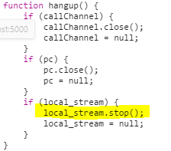

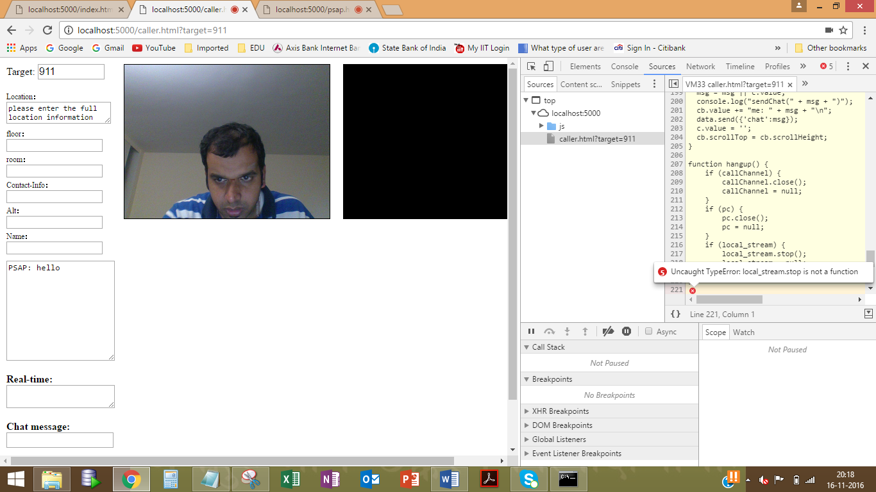

1. I see following messages in the console. Does it have any impact on the functionality?

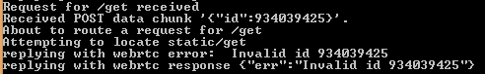

Although, I did not see any issues in the front end.

1. After refreshing the PSAP app screen, I see following error in the console.

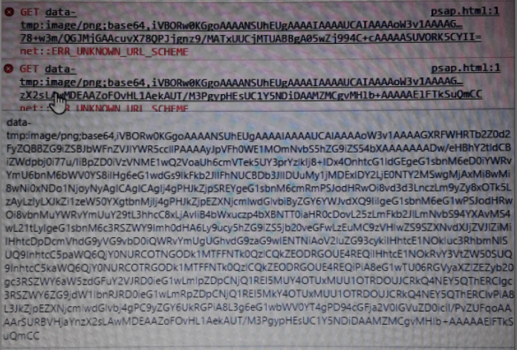

1. Caller has dialled 911 and PSAP user has not accepted the call yet, caller entered some message in chat message area and PSAP user able to see that message without accepting the call is this expected? Please confirm. Also, I see following exceptions in the console (at PSAP user side).



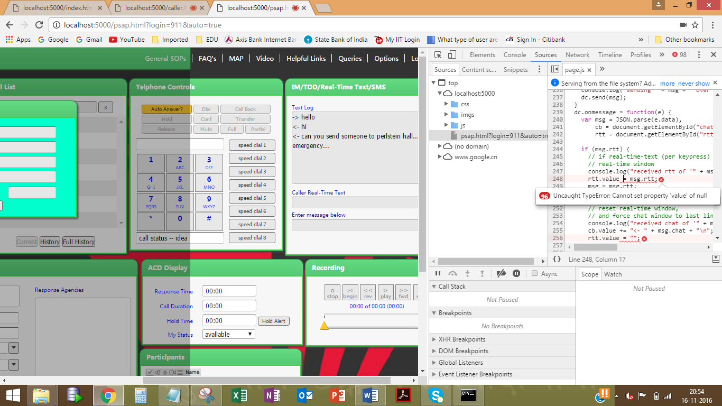

1. None of the buttons are working under Call Information, Call List, Telephone Controls, IM/TDD/Real-Time Text/SMS, Emergency Information, ACD Display, Recording, Participants.
2. Accept the call and close the video window in PSAP app page. Disconnect the call from caller end and Enter some message in IM/TDD/Real-Time Text/SMS window. I see Uncaught DOMException message in the console.

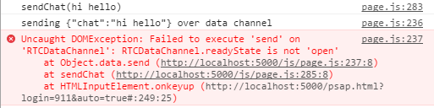

Check the location and end call functionality… (try with mobile)

Test more on PSAP side

Can you ask him to send that codes which he fixed just now?